

**BIRDS-5 Project**

**EM Thermal Vacuum Test Procedure**

Kyushu Institute of Technology

Laboratory of Lean Satellite Enterprises and In-Orbit Experiments (LaSEINE)





|  |  |  |  |
| --- | --- | --- | --- |
| **Date** | **Version Number** | **Writer** | **Annotations** |
| 2021/8/15 | v1.0 | Takashi Oshiro | First Draft |
|  |  |  |  |
|  |  |  |  |
|  |  |  |  |
|  |  |  |  |
|  |  |  |  |
|  |  |  |  |
|  |  |  |  |

**`**

**Contents**

1. Introduction 3

1.1. General 3

1.2. Objectives 3

1.3. Scope 3

2. Reference 3

3. Nomenclature 3

3.1. Acronyms 3

3.2. Symbols 4

4. Test Purpose 4

4.1. Overall test purpose 4

4.2. Corresponding requirements from RAS 4

5. Test Description 4

5.1. Test place and time 4

5.1.1. Test date 4

5.1.2. Test place 4

5.2. Test contents 5

5.3. Test article 5

5.4. Test flow, level and conditions 6

6. Test Facility, Set-Up and Equipment 8

6.1. Test Facility 8

6.2. Test Setup 9

6.3. Thermal Cycle Profile 10

6.4. Heater Positions 11

6.5. Thermocouple Positions 13

6.6. Attachment of Thermocouples 18

6.7. Placement of Satellite inside the Small Vacuum Chamber 19

6.8. Equipment and Measuring Instruments 19

7. Test Schedule 20

8. Detailed Test Procedure 20

9. Test Output 23

9.1. Data analysis strategy 23

9.2. Test report 23

10. Quality Insurance 24

11. Personnel Assignment 24

12. Safety Requirement 25

1. **Introduction**
   1. **General**

The Thermal Vacuum Test (TVT) of the Engineering Model (EM) of BIRDS-5 satellite shall pass qualification requirements under vacuum conditions and temperature extremes which simulate predicted space environment.

* 1. **Objectives**

The following are the test objectives:

* Check and analyze various satellite point temperatures under extreme hot and cold conditions.
* Check and analyze functionality and operation of the satellite under the defined temperature range (extreme hot, extreme cold and middle temperature conditions).
* Check and analyze operation of thermal monitors under the defined temperature range.
  1. **Scope**

This document is applied to thermal vacuum test for BIRDS-5 EM using the small vacuum chamber at the Center for Nanosatellite Testing (CeNT) at Kyutech.

1. **Reference**

|  |  |  |
| --- | --- | --- |
| **Document number** | **Document description** | **Revision level or Release date** |
| ISBN 1-884989-11-X | Spacecraft Thermal Control Handbook | Second Edition, 2002 |

1. **Nomenclature**

**3.1. Acronyms**

|  |  |
| --- | --- |
| ADCS | Attitude Determination and Control System |
| COM-UHF TRX | UHF transceiver board |
| EM | Engineering Model |
| EPS | Electric Power Subsystem |
| GS | Ground Station |
| LN2 | Liquid Nitrogen |
| OBC | Onboard Computer |
| PCB | Printed Circuit Board |
| SP | Solar Panel |
| TC | Thermocouple |
| TVT | Thermal Vacuum Test |

**3.2 Symbols**

|  |  |
| --- | --- |
| °C | Degree Celsius |
| Ω | Ohm (resistance value) |
| W | Watt |
| Pa | Pascal |

1. **Test Purpose**

**4.1. Overall test purpose**

1. Measure temperatures at different satellite points under extreme hot and cold conditions.
2. Check functionality and operation of the satellite under defined temperature range (extreme hot, extreme cold and room temperature condition).
3. Check operation of thermal monitors under defined temperature range.

**4.2. Requirements**

Table 1. Requirements to be satisfied by the test

|  |  |
| --- | --- |
| **Requirement Number** | **Requirement Description** |
| **N/A** | All of BIRDS-5 components/parts temperature range shall be within the operating temperature ranges. |
| **DR 1** | Allowable internal temperature range shall be from -15ºC to 55ºC. |
| **DR 2** | Allowable external temperature range shall be from -40ºC to +80ºC. |
| **DR 3** | Temperature of the battery shall be monitored. |
| **DR 4** | Internal boards shall provide temperature data. |
| **DR 5** | The battery shall be kept within temperature range (0ºC to 40ºC). |

1. **Test Description**

**5.1. Test Place and Time**

**5.1.1. Test Date**

The thermal vacuum test will be conducted from **August 16 to August 20, 2021** (5 days)which includes setup preparation, the actual test cycles (with satellite functional test) and setup recovery.

**5.1.2. Test Place**

Center for Nanosatellite Testing

Laboratory of Spacecraft Environment Interaction Engineering

Kyushu Institute of technology

* 1. Sensui, Tobata, Kitakyushu, 804-8550 Fukuoka, Japan

**5.2. Test Contents**

The test shall consist of:

1. Preparation of the satellite, stand, thermocouples (TCs), sheet heaters, connectors, GS setup and other materials to be used for the test
2. Attachment of TCs and heaters to the satellite and checking the response/resistance
3. Satellite assembly and checking of satellite functionality in normal laboratory setup (in BIRDS room condition)
4. Installation of the satellite, stand, TCs, external heaters, and connectors inside the vacuum chamber and checking connectivity and responses.
5. Checking the satellite functionality inside the vacuum chamber before closing (atmospheric condition)
6. Vacuuming
7. Measurement of temperature of various satellite points in vacuum condition during the thermal vacuum test (especially at extreme cold condition and extreme hot condition)
8. Checking the satellite functionality during the thermal vacuum test (especially at extreme cold condition and extreme hot condition)
9. Setup recovery and removing the satellite from the vacuum chamber

**5.3. Test Article**

The test article description is shown in Table 2.

Table 2. Test article description

|  |  |  |  |
| --- | --- | --- | --- |
| **No.** | **Article name** | **Quantity** | **Manufacturer** |
| **1** | BIRDS-5 1U EM | 1 | - |
| **2** | BIRDS-5 2U EM | 1 |  |

The FM 3D model is shown in Figure 1.

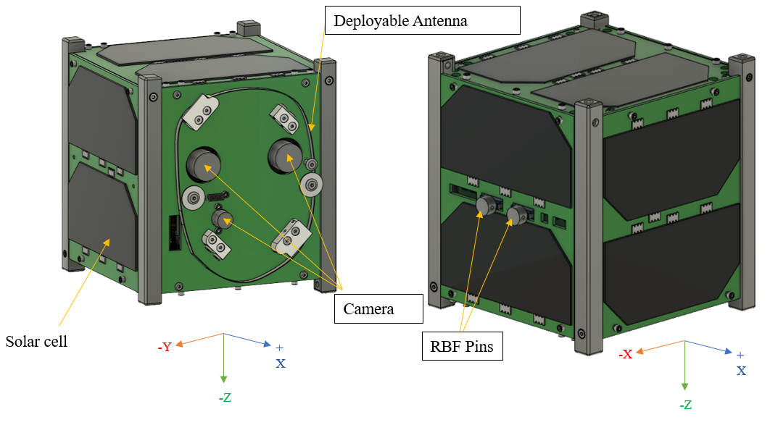

**Figure 1. BIRDS-5 1U EM 3D model**

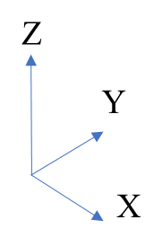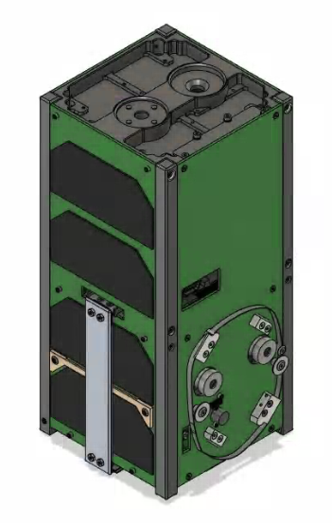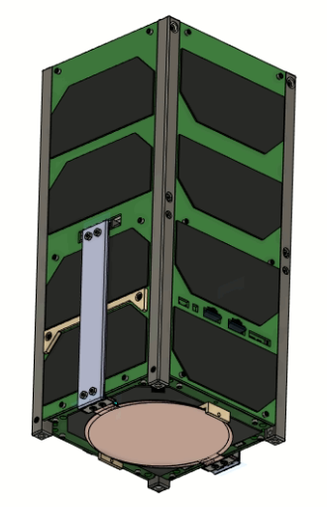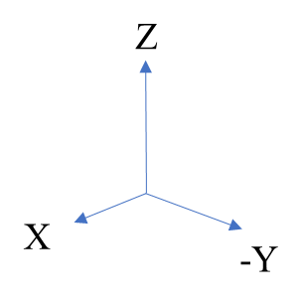

**Figure 2. BIRDS-5 2U EM 3D model**

**5.4. Test Flow, Level and Conditions**

Pressure, temperature and testing duration are described below

* Pressure: the chamber pressure shall be kept below 1 x 10-3 Pa during all conditions of the thermal vacuum test. In this pressure range, heat exchange by molecular flow is negligible.
* Test flow:

Table 3 shows the condition of heater power for thermal vacuum test. The power conditions shall be based on the calculation from orbit analysis for worst cases.

**Table 3. Heater power in thermal vacuum test**

|  |  |  |  |  |  |  |  |  |  |
| --- | --- | --- | --- | --- | --- | --- | --- | --- | --- |
| Phase | | Duration  (Hours) | Time  (HH:MM) | +X Sheet Heater Power (W) | -X Sheet Heater Power (W) | +Y Sheet Heater Power (W) | -Y Sheet Heater Power (W) | +Z Sheet Heater Power (W) | -Z Sheet Heater Power (W) |
| FT0 | |  |  |  |  |  |  |  |  |
| Vacuuming | |  |  | 0 | 0 | 0 | 0 |  |  |
| Vacuum reached, room temperature | |  |  | 0 | 0 | 0 | 0 |  |  |
| FT1 | |  |  |  |  |  |  |  |  |
| Cold Ramp 1 | Start |  |  |  |  |  |  |  |  |
| Cold Ramp 1 | Stop |  |  |  |  |  |  |
| Cold Soak 1 | Start |  |  |  |  |  |  |  |  |
| Cold Soak 1 | Stop |  |  |  |  |  |  |
| Cold Start |  |  |  |  |  |  |  |  |  |
| FT2 |  |  |  |  |  |  |  |  |  |
| Hot Ramp 1 | Start |  |  |  |  |  |  |  |  |
| Hot Ramp 1 | Stop |  |  |  |  |  |  |
| Hot Soak 1 | Start |  |  |  |  |  |  |  |  |
| Hot Soak 1 | Stop |  |  |  |  |  |  |
| FT3 |  |  |  |  |  |  |  |  |  |
| Cold Ramp 2 | Start |  |  |  |  |  |  |  |  |
| Cold Ramp 2 | Stop |  |  |  |  |  |  |
| Cold Soak 2 | Start |  |  |  |  |  |  |  |  |
| Cold Soak 2 | Stop |  |  |  |  |  |  |
| FT4 |  |  |  |  |  |  |  |  |  |
| Hot Ramp 2 | Start |  |  |  |  |  |  |  |  |
| Hot Ramp 2 | Stop |  |  |  |  |  |  |
| Hot Soak 2 | Start |  |  |  |  |  |  |  |  |
| Hot Soak 2 | Stop |  |  |  |  |  |  |
| FT5 |  |  |  |  |  |  |  |  |  |
| Ramp down to room temperature | |  |  |  |  |  |  |  |  |
| FT6 | |  |  |  |  |  |  |  |  |
| De-vacuuming and recovery | |  |  |  |  |  |  |  |  |
| FT7 | |  |  |  |  |  |  |  |  |

1. **Test Facility, Setup and Equipment**
   1. **Test Facility**

Specifications of the thermal vacuum chamber are shown in Table 4.

**Table 4. Small thermal vacuum chamber specification**

|  |  |  |
| --- | --- | --- |
| No. | Items | Specification |
| 1 | Name | Vacuum thermal shock test equipment |
| 2 | Manufacturer | ULVAC KYUSHU CORPORATION |
| 3 | Size | Overall length 100 (each tub 50) x Ф30 |
| 4 | Material | SUS 304 |
| 5 | Ultimate Vacuum | 1.0 x 10-5 Pa ~ 1.0 x 10-3 Pa |
| 6 | Temperature | -150ºC ~ +150ºC |
| 7 | Thermal Input | No rail: shroud (cold), sheet heater (hot)  With rail: shroud (cold), IR lamp (hot) |
| 8 | Dimensions | No rail: 200 x 150 x 150  With rail: 100 x 100 x 100 |
| 9 | Characteristics | -Separate into hot and low temperature side  -Simulate exponential thermal input by moving a satellite in the chamber |

Figure 2 is an illustration of CeNT’s small thermal vacuum chamber.

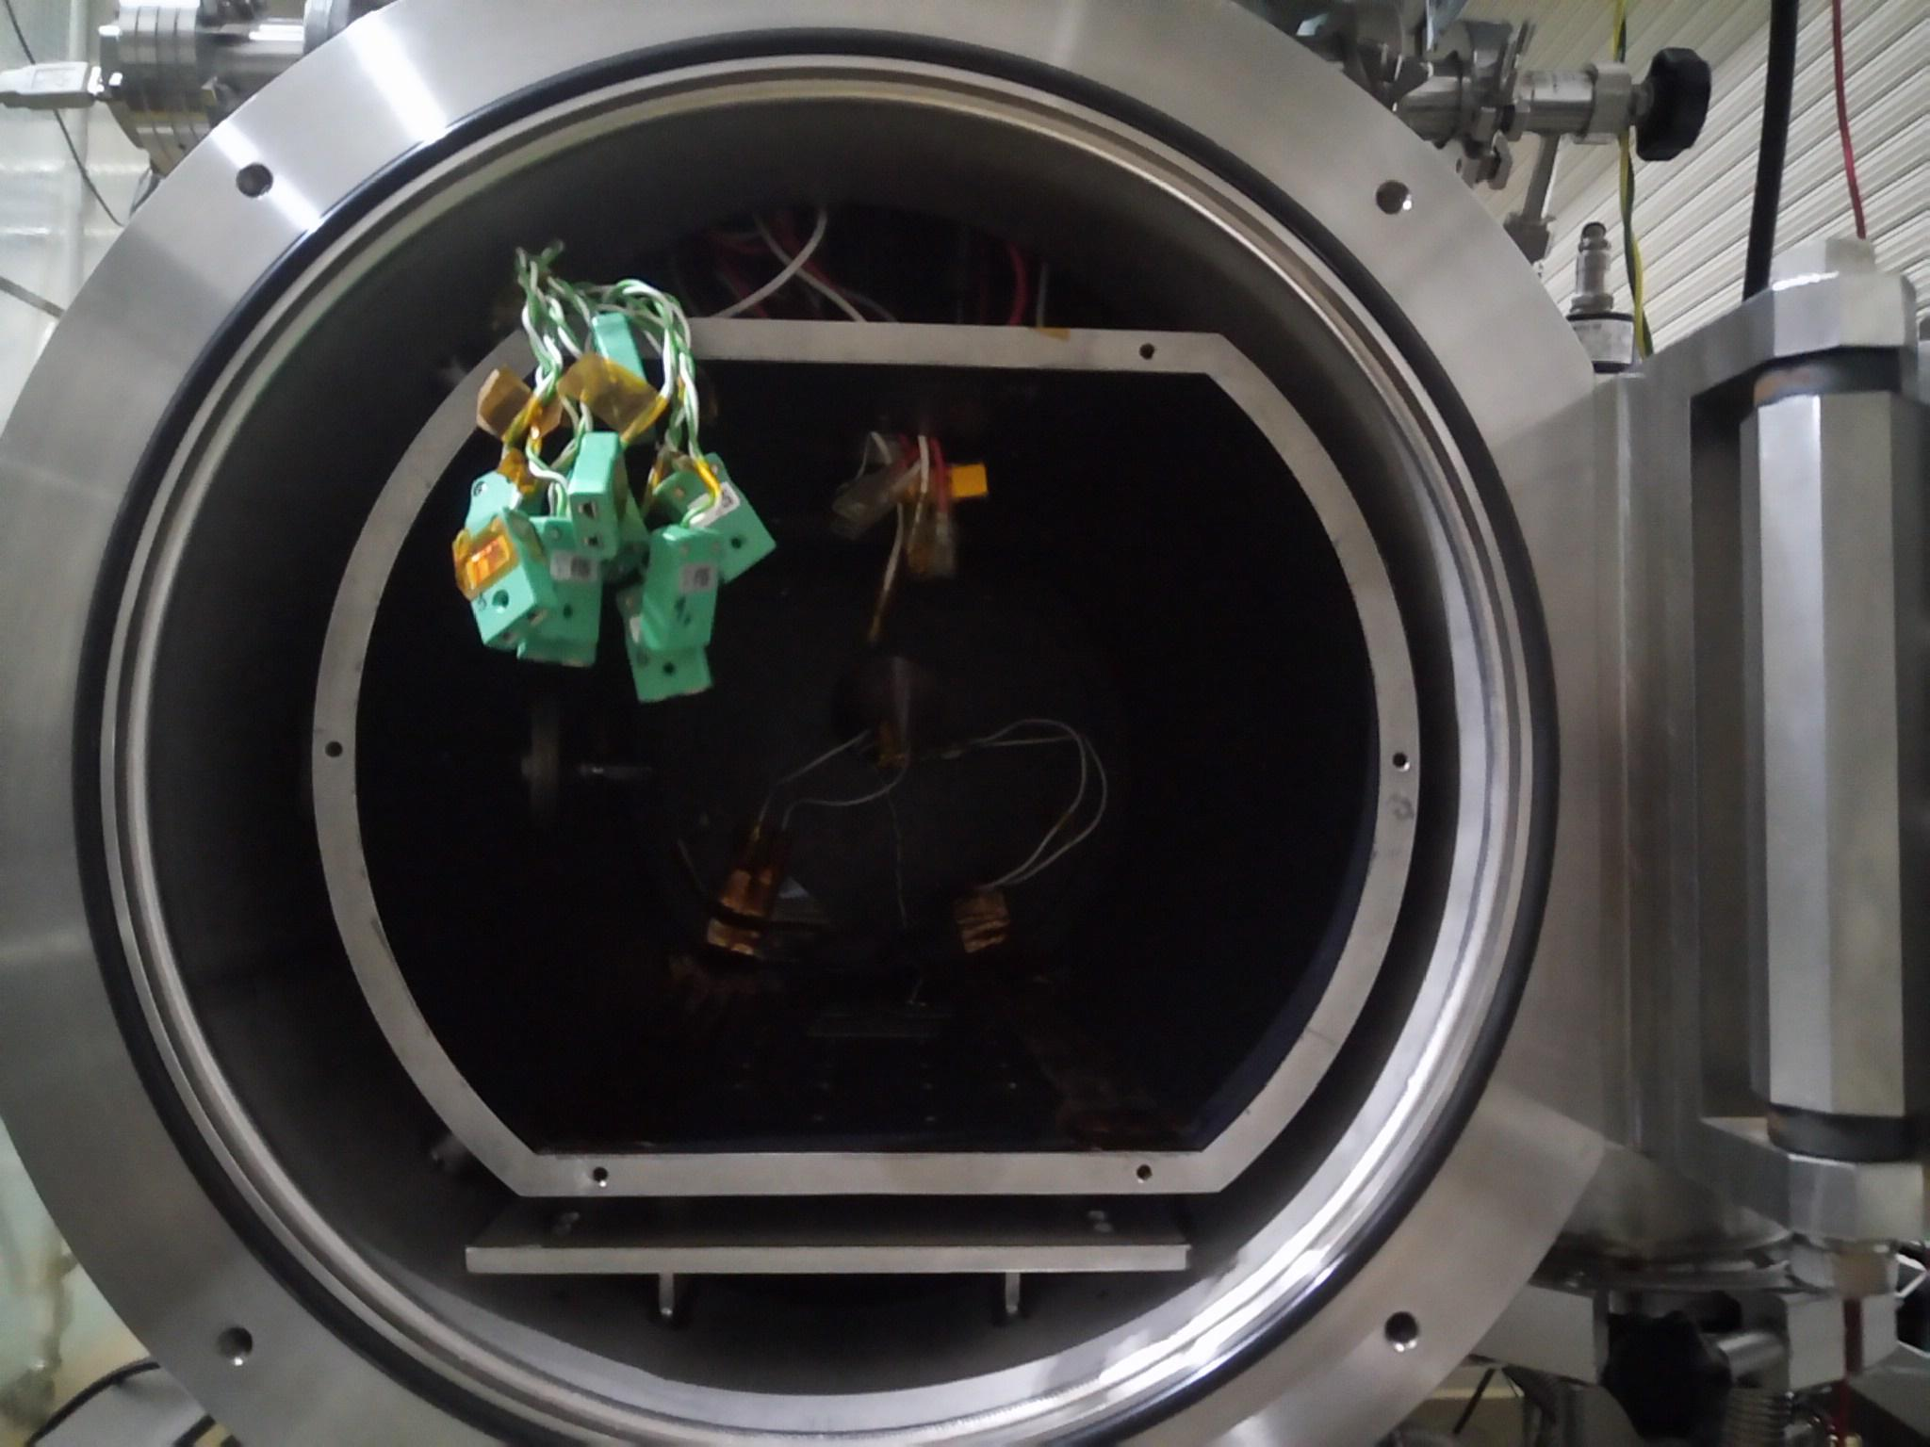

**Figure 3. Small Thermal Vacuum Chamber at CeNT**

* 1. **Test Setup**

The setup diagrams are shown below.

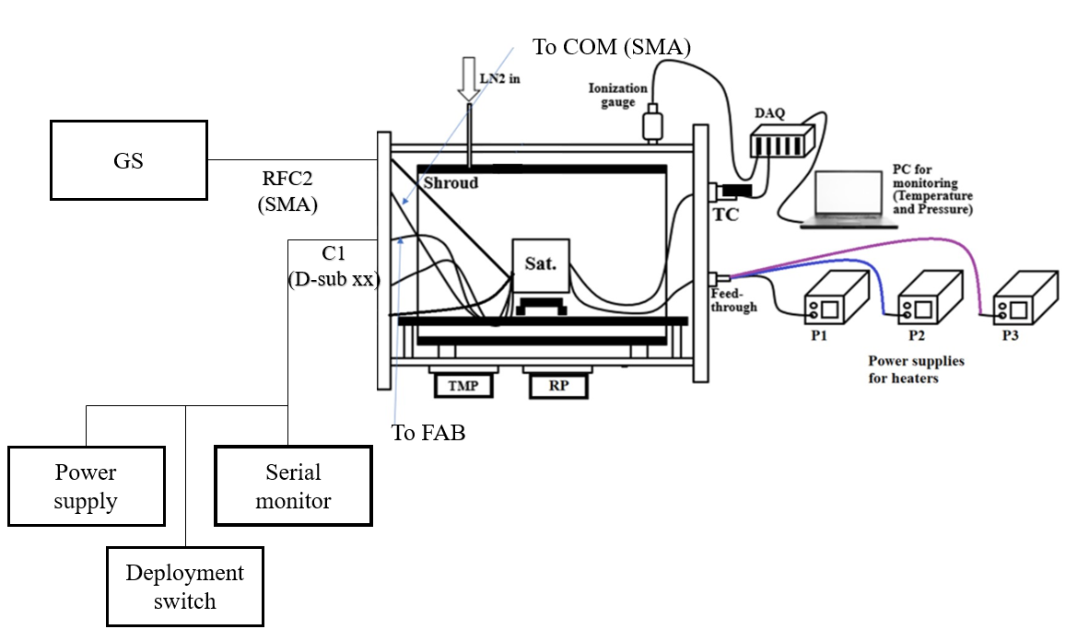

**Figure 4. Overall test setup**

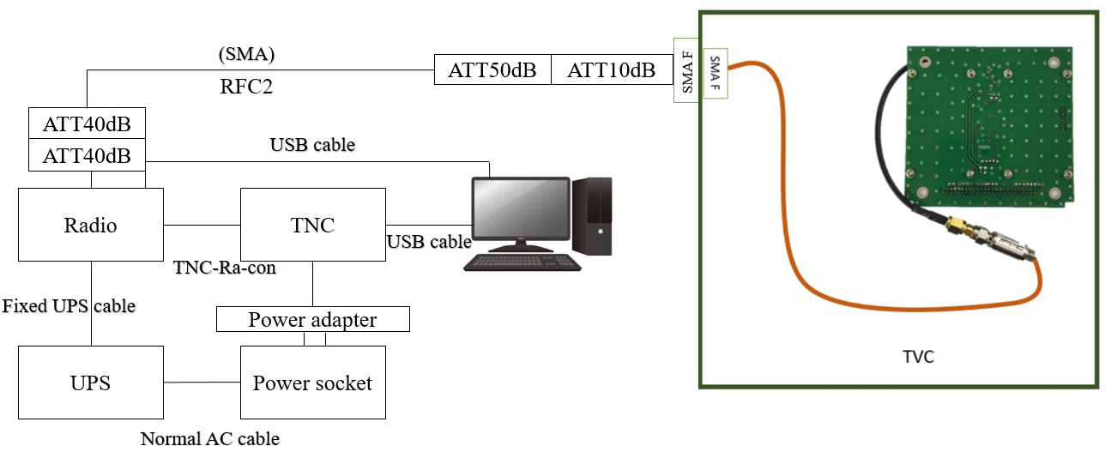

**Figure 5. Connection from COM-UHF transceiver board to GS equipment**

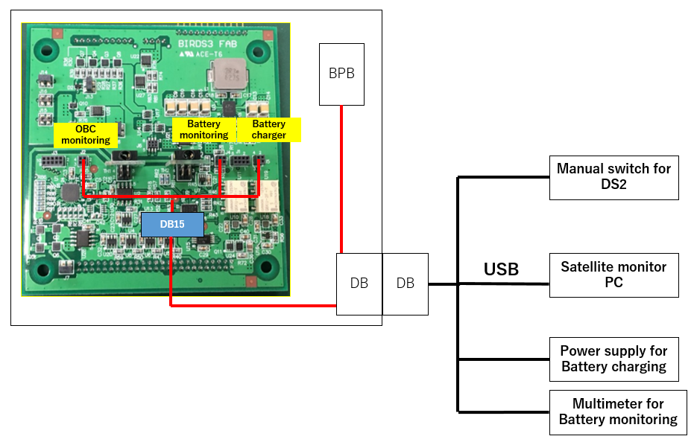

**Figure 6. Connection from FAB to programming board, satellite monitoring PC, manual switch for RBF and power supply for battery charging**

* 1. **Thermal Cycle Profile**
* The test will be conducted with 2 cycles (2 cold and 2 hot) as shown in Figure 7. At the extreme cold temperature and at the extreme hot temperature of each cycle, soaking time is 2 hours then followed by functionality tests of subsystems and missions within the next 1 hour.
* There are a total 16 temperature measurement points for the 1U satellite, including the six on the external panels points. For the 2U satellite, there are 17 temperature measurement points.
* The monitoring/control temperature is battery for cold case and battery and COM for hot.
* The temperature ramp-up (worst cold to worst hot) rate is 45°C/hour and the temperature ramp-down (worst hot to worst cold) is 30°C/hour.
* The worst cold condition for battery is 0°C and will be used as controls.
* The worst hot condition which is control is the battery at +40°C or +50°C of COM, which ever arrives first.
* The battery temperature will be controlled to get lowest +5°C in a short time during the last cold soak phase to verify the battery operation in worst cold case.

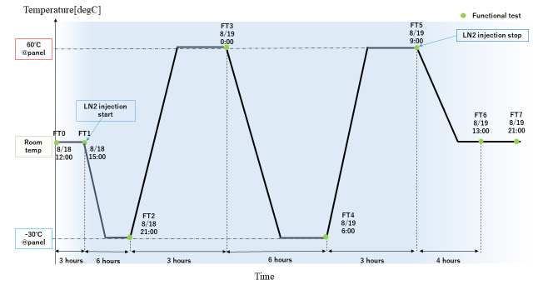

**Figure 7. Test Cycle Profile**

* 1. **Heater Positions**

Table 5 provides the sheet heater parameters such as position, size, resistance and maximum power that can be used for the test.

**Table 5. Heater Parameters**

|  |  |  |  |  |  |  |
| --- | --- | --- | --- | --- | --- | --- |
| Heater Number | Position | Size [mm] | Resistance (Ω) | Total Resistance (Ω) | Maximum Power (W) | Power Supply Number |
| H1 | +X |  |  |  |  |  |
| H2 | -X |  |  |  |  |  |
| H3 | +Y |  |  |  |  |  |
| H4 | -Y |  |  |  |  |  |
| H5 | +Z |  |  |  |  |  |
| H6 | -Z |  |  |  |  |  |

The placement of the sheet heaters is shown in Figure 8 below.

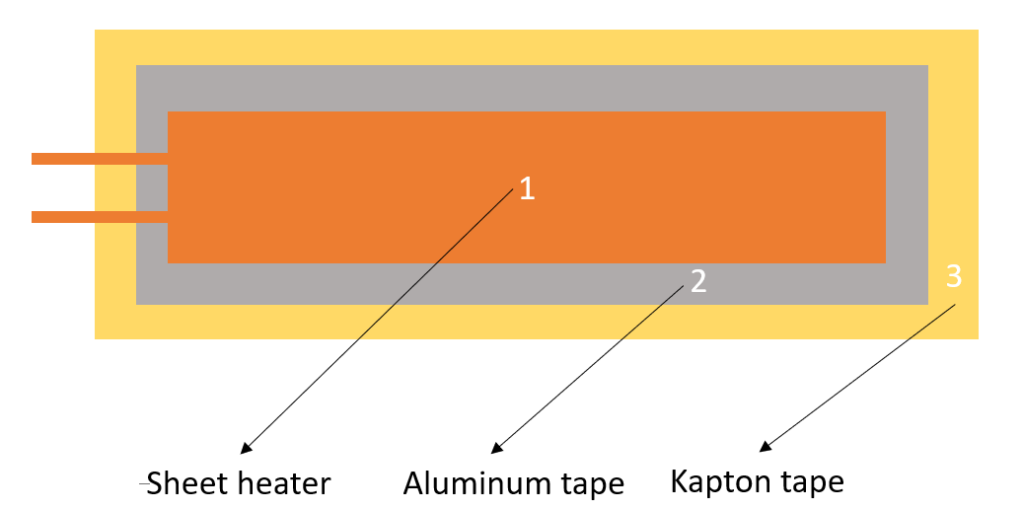

**Figure 8. Heater configuration**

* 1. **Thermocouple Positions**

The positions of thermocouples are summarized in Table 6.

**Table 6. Positions of Thermocouples (K type)**

|  |  |  |  |  |  |
| --- | --- | --- | --- | --- | --- |
|  | **Position** | **TC Number** | **Connector Number Inside of Chamber** | **TC Number in PC** | **Measurement Point** |
| **1** | Shroud Top |  |  | 9 |  |
| **2** | Shroud Bottom |  |  | 10 |  |
| **3** | LN2 Control |  |  | 11 |  |
| **4** | Battery Box – Front | K01 | 1 | 0 |  |
| **5** | Battery Box – Back | K02 | 2 | 1 |  |
| **6** | Battery – Inside Battery Box | K03 | 3 | 2 |  |
| **7** | Front Access Board | K04 | 4 | 3 | Processor |
| **8** | OBC Board | K05 | 5 | 4 | Processor |
| **9** | COM-UHF TRX Board | K06 | 6 | 5 | Processor |
| **10** | Mission Board 1 | K07 | 7 | 6 | Processor |
| **11** | Mission Board 2 | K08 | 8 | 7 | Processor |
| **12** | Rear Access Board | K09 | 9 | 8 |  |
| **13** | -X | K10 | 10 | 9 |  |
| **14** | +X | K11 | 11 | 10 |  |
| **15** | +Y | K12 | 12 | 11 |  |
| **16** | -Y | K13 | 14 | 13 |  |
| **17** | +Z | K14 | 15 | 14 |  |
| **18** | -Z | K15 | 17 | 16 |  |
| **19** | CPLD Backplane Board | K16 | 21 | 20 | CPLD |
| **20** | Front Heater(+Z P2) | FR | 23 | 22 |  |
| **21** | Back Heater(-Z P2) | BA | 24 | 23 |  |
| **22** | Top Heater(-X P3) | TO | 25 | 24 |  |
| **23** | Bottom Heater(+X P3) | BO | 26 | 25 |  |
| **24** | Right Heater(+Y P4) | RI | 27 | 26 |  |
| **25** | Left Heater(-Y P4) | LE | 28 | 27 |  |
| **26** | PINO | K21 |  |  |  |

Figure 10 to Figure 25 show the position of thermocouples will be attached to the satellite:

|  |  |
| --- | --- |
| **Figure 9.** | **Figure 10.** |
| **Figure 11.** | **Figure 12**. |
| **Figure 13.** | **Figure 14.** |
| **Figure 15.** | **Figure 16.** |
| **Figure 17.** | **Figure 18.** |
| **Figure 19.** | **Figure 20.** |
| **Figure 21.** | **Figure 22.** |
| **Figure 23.** | **Figure 24.** |

2U below

|  |  |  |  |  |  |
| --- | --- | --- | --- | --- | --- |
|  | **Position** | **TC Number** | **Connector Number Inside of Chamber** | **TC Number in PC** | **Measurement Point** |
| **1** | Shroud Top |  |  | 9 |  |
| **2** | Shroud Bottom |  |  | 10 |  |
| **3** | LN2 Control |  |  | 11 |  |
| **4** | Battery Box – Front | K01 | 1 | 0 |  |
| **5** | Battery Box – Back | K02 | 2 | 1 |  |
| **6** | Battery – Inside Battery Box | K03 | 3 | 2 |  |
| **7** | Front Access Board | K04 | 4 | 3 | Processor |
| **8** | OBC Board | K05 | 5 | 4 | Processor |
| **9** | COM-UHF TRX Board | K06 | 6 | 5 | Processor |
| **10** | Mission Board 1 | K07 | 7 | 6 | Processor |
| **11** | Mission Board 2 | K08 | 8 | 7 | Processor |
| **12** | Rear Access Board | K09 | 9 | 8 |  |
| **13** | -X | K10 | 10 | 9 |  |
| **14** | +X | K11 | 11 | 10 |  |
| **15** | +Y | K12 | 12 | 11 |  |
| **16** | -Y | K13 | 14 | 13 |  |
| **17** | +Z | K14 | 15 | 14 |  |
| **18** | ~~-Z~~ | ~~K15~~ | ~~17~~ | ~~16~~ |  |
| **19** | CPLD Backplane Board | K16 | 21 | 20 | CPLD |
| **20** | Front Top Heater(-X ) |  | 23 | 22 |  |
| **21** | Back Top Heater(-X ) |  | 24 | 23 |  |
| **22** | Front Bottom Heater(+X) |  | 25 | 24 |  |
| **23** | Back Bottom Heater(+X) |  | 26 | 25 |  |
| **24** | Front Right Heater(+Y) |  | 27 | 26 |  |
| **25** | Back Right Heater(+ ) |  | 28 | 27 |  |
| **26** | Front Left Heater(-Y) |  | 29 | 28 |  |
| **27** | Back Left Heater(+Y) |  | 30 | 29 |  |
| **26** | PINO | K21 | 17 | 16 |  |

* 1. **Attachment of Thermocouples**

Figure 25 shows the steps of attaching the thermocouples to satellite surfaces and components.

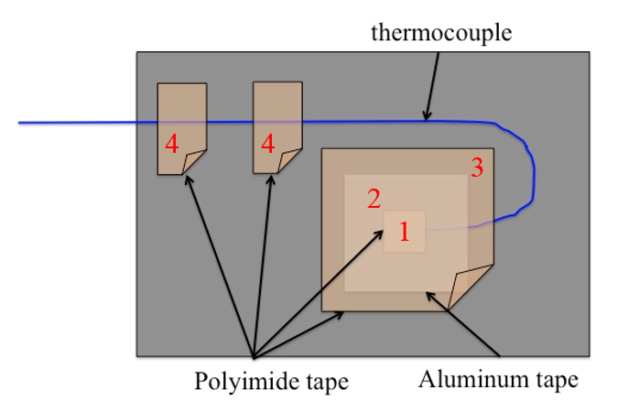

**Figure 25. Attach Thermocouple**

* Step 1: Cover thermocouple tips by a small piece of polyimide tape
* Step 2: Fix the thermocouple terminal using aluminum tape
* Step 3: Cover the aluminum tape by polyimide tape
* Step 4: Fix the thermocouple wire by polyimide tapes
  1. **Placement of satellite inside the small vacuum chamber**

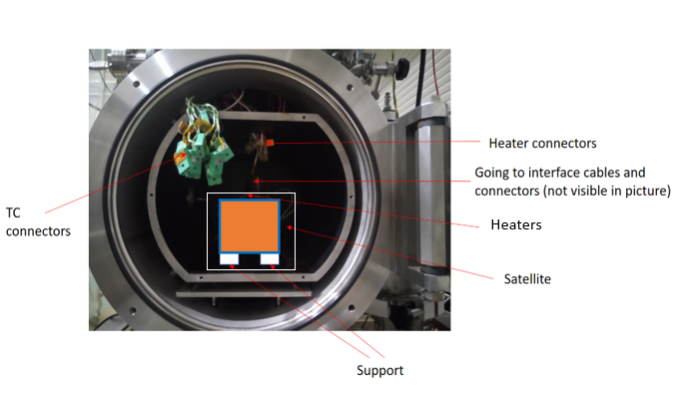

**Figure 26. Placement of the satellite inside the small vacuum chamber**

* 1. **Equipment and Measuring Instruments**

**Table 7** shows a list of equipment needed during the thermal vacuum test.

**Table 7.** Equipment and measuring instruments details

|  |  |  |  |  |
| --- | --- | --- | --- | --- |
| No | Equipment | Quantity | Model | Comments |
| 1 | Thermocouple | 20 | Type-K | -180 to +1300 °C |
| 2 | Sheet Heater | 3 |  |  |
| 3 | Sheet Heater | 2 |  |  |
| 4 | Data acquisition PC | 1 | Desktop PC | For chamber control |
| 5 | DAQ-mx | 4 | NI 9213 | 24 bit ADC |
| 6 | Power Supply | 4 |  | 0-320V |
| 7 | Camera | 1 | D3200 | 24 Mpx |
| 8 | Transceiver | 1 | IC-9100 | For functional test |
| 9 | Attenuator | 3 |  | For functional test |
| 11 | Functional Test PC | 2 | N/A | For functional test |
| 12 | Terminal Node Controller | 1 | KPC-9612+ | For functional test |

1. **Test Schedule**

The test schedule is shown in Table 8 below, the schedule is tentative and can be changed base on the actual test conditions.

**Table 8.** Test schedule

|  |  |  |  |  |  |  |  |  |  |  |  |  |  |  |
| --- | --- | --- | --- | --- | --- | --- | --- | --- | --- | --- | --- | --- | --- | --- |
|  | 8/16  AM PM | | 8/17  AM PM | | 8/18  AM PM | | 8/19  AM PM | | 8/20  AM PM | | 8/21  AM PM | | 8/22  AM PM | |
| Preparation of the satellite, thermocouples (TCs), sheet heaters, connectors, GS setup and other materials to be used for the test |  |  |  |  |  |  |  |  |  |  |  |  |  |  |
| Attachment of TCs and heaters to the satellite and checking the response/resistance |  |  |  |  |  |  |  |  |  |  |  |  |  |  |
| Satellite assembly and checking of satellite functionality in normal laboratory setup (in BIRDS Room condition)  Installation of the satellite, TCs, heaters, and connectors inside the vacuum chamber and checking connectivity and responses. |  |  |  |  |  |  |  |  |  |  |  |  |  |  |
| Checking the satellite functionality inside the vacuum chamber before closing (atmospheric condition) |  |  |  |  |  |  |  |  |  |  |  |  |  |  |
| Vacuuming |  |  |  |  |  |  |  |  |  |  |  |  |  |  |
| Inject LN2 |  |  |  |  |  |  |  |  |  |  |  |  |  |  |
| Thermal Cycle |  |  |  |  |  |  |  |  |  |  |  |  |  |  |
| De-vacuuming, setup recovery and removing the satellite from the vacuum chamber |  |  |  |  |  |  |  |  |  |  |  |  |  |  |

1. **Detailed Test Procedure**

The detail test procedures shown in Table 9 with tasks need to be done before, during and after the test, the person in charge of each task should check the task once it finished.

|  |
| --- |
| Verification |
| Preparation and checking the satellite and chamber |
| Make vacuum and conduct the thermal test and functional test |
| Stop the test, clean up and check the satellite |

**Table 9.** Detailed test procedure

|  |  |  |
| --- | --- | --- |
| **No.** | **Procedure** | **Check** |
| 0 | Verify all satellite functionalities and operation (preliminary, in BIRDS Clean Room – SVBL 3F) |  |
| 1 | Prepare and check thermocouples |  |
| 2 | Prepare and check heaters |  |
| 3 | Check chamber's heater connections |  |
| 4 | Check chamber's thermocouple connections |  |
| 5 | Check chamber's D-Sub and RF port connections |  |
| 6 | Disassemble structure and center box |  |
| 7 | Attach thermocouples and heaters to BIRDS-5 (see Figures 9-24) |  |
| 8 | Take photos and note the heaters’ and TCs’ positions and number |  |
| 9 | Reassemble satellite and check thermocouples and heaters connection |  |
| 10 | Check satellite functionalities |  |
| 11 | Move satellite to the chamber |  |
| 12 | Install the satellite in the chamber (see Fig. 26) |  |
| 13 | Check again all heaters’ and TCs’ response on the PC |  |
| 14 | Check satellite functionalities |  |
| 15 | Close the chamber |  |
| 16 | Make vacuum |  | Duration | Time | Check Power[W] of **external** heaters |  |
|  |  |  | (Hours) | (HH:MM) |  |  |
| 17 | Inject LN2 |  |  |  |  |  |
| 18 | Start cold ramp 1 |  |  |  |  |  |
| 19 | Start cold soak 1 |  |  |  |  |  |
| 20 | Satellite functional test 1-C battery charging |  |  |  |  |  |
| 21 | Start hot ramp 1 |  |  |  |  |  |
| 22 | Start hot soak 1 |  |  |  |  |  |
| 23 | Satellite functional test 1-H, battery charging |  |  |  |  |  |
| 24 | Start cold ramp 2 |  |  |  |  |  |
| 25 | Start cold soak 2 |  |  |  |  |  |
| 26 | Satellite functional test 2-C battery charging |  |  |  |  |  |
| 27 | Start hot ramp 2 |  |  |  |  |  |
| 28 | Start hot soak 2 |  |  |  |  |  |
| 29 | Satellite functional test 2-H, battery charging |  |  |  |  |  |
| 39 | Start ramp down to room temperature |  |  |  |  |  |
| 40 | Satellite functional test at room temperature |  |  |  |  |  |
| 41 | Stop LN2 injection |  |  |  |  |  |
| 42 | Turn on chamber heater to increase chamber temperature |  |  |  |  |  |
| 43 | Open chamber, move satellite to clean room |  |  |  |  |  |
| 44 | Satellite functional testing |  |  |  |  |  |
| 45 | Disassemble satellite |  |  |  |  |  |
| 46 | Remove TCs and heaters |  |  |  |  |  |
| 47 |  |  |  |  |  |  |

1. **Test Output**

**9.1. Data analysis strategy**

Table 10 below show the operating temperature range of KITSUNE satellite. The temperature of each subsystem during the test should be inside of operating temperature range.

**Table 10. Subsystem operating temperature range**

|  |  |  |  |
| --- | --- | --- | --- |
| **Subsystem** | **Lowest (°C)** | **Highest (°C)** |  |
| FAB | -20°C | 85°C |  |
| OBC/EPS Board | -40°C | 85°C |  |
| Battery | 0°C | 40°C | Hot + Cold Control Case |
| COM | -20°C | 60°C |  |
| Backplane board | -40°C | 105°C |  |
| Mission Board 1 | °C | °C |  |
| Mission Board 2 | -40°C | 85°C | RPI |
| RAB | -40°C | 85°C | RPI |
| External panel | -40°C | 85°C |  |
| PINO module | °C | °C |  |

**9.2. Test report**

* Temperature profile of all measurement points during the test.
* Results on functionality tests
* Evaluation of the test results.

1. **Quality Insurance**

|  |  |
| --- | --- |
| Temperature [oC] | : 20 ± 5 |
| Humidity [%] | : 70 ± 10 |
| Atmosphere | : 10^-5 Pa |

1. **Personnel Assignment**

Tables 11 show the personnel assignment for the thermal vacuum test.

**Table 11. Personnel Assignment During Setup Preparation**

|  |  |
| --- | --- |
| Task | Responsible Person |
| Ground Station Equipment | Ramson, Edgar |
| Preparation and installation of heaters and thermocouples | Oshiro, Victor, Joseph |
| D-sub Connector Preparation | Keenan, Otani |
| Battery Charging Setup | Derrick |
| Antenna preparation | Iwase |
| Documentation | Oshiro |
| Support | Bonny, Timothy, Kamitani, Fukudome |
| TVT Lead | Masui sensei |
| Team Management | Victor |

1. **Safety Requirement**

During the test period, in consideration of the safety of work, strictly observe the following matters:

1. During testing, the field officer shall supervise all work and instruct properly to assure the safety of work.
2. Use a crane or a handcart to move any heavy item with anticipated risk.
3. The ceiling crane shall be operated only by licensed personnel. I-bolt / lifting equipment should be inspected each time before operating the crane. No entry to the area under the suspended material is permitted.
4. During testing, keep unnecessary items away from the testing machine.
5. Gloves shall be worn when handling a satellite or sensors.
6. Do not place any item on safety-related motion lines, such as the emergency exit, corridor, fire extinguishers, etc.
7. When a high voltage apparatus is used, turn off the power before inspecting, touching, or modifying, etc.
8. In the case of a natural disaster or a serious accident, take emergency measures and prevent secondary accidents immediately. Then communicate via the following emergency communication links shown below in Figure 27.

|  |
| --- |
| **新しい画像.png** |
| **Figure 34.** Emergency procedure flow chart |

|  |
| --- |
| 1. What to say in Japanese 2. You are the **center, 4th floor**   Kyushu kogyo daigaku, **kogakubu no sogo kenkyu ichi-goto, yonkai de** ________**nin fushosha (= injured)/kasai (= fire)** ga hassei shimasita. Watashi wa ________ (your name) desu.  Kyushu Institute of Technology, General Research Building No. 1, 4th floor. There are ________ people **injured/**There is a **fire**. I am ________ (your name).   1. You are at **SVBL, 1st floor**   Kyushu kogyo daigaku, **kogakubu no sogo kenkyu ni-goto, ichikai de ________nin fushosha (= injured)/kasai (= fire)** ga hassei shimasita. Watashi wa ________ (your name) desu.  Kyushu Institute of Technology, General Research Building No. 2, 1st floor. There are ________ people **injured/**There is a **fire**. I am ________ (your name).   1. You are at **SVBL, 2nd floor**   Kyushu kogyo daigaku, **kogakubu no sogo kenkyu ni-goto, nikai de ________nin fushosha (= injured)/kasai (= fire)** ga hassei shimasita. Watashi wa ________ (your name) desu.  Kyushu Institute of Technology, General Research Building No. 2, 2nd floor. There are ________ people **injured/**There is a **fire**. I am ________ (your name).   1. You are at **SVBL, 3rd floor**   Kyushu kogyo daigaku, **kogakubu no sogo kenkyu ni-goto, sankai de ________nin fushosha (= injured)/kasai (= fire)** ga hassei shimasita. Watashi wa ________ (your name) desu.  Kyushu Institute of Technology, General Research Building No. 2, 3rd floor. There are ________ people **injured/**There is a **fire**. I am ________ (your name). |